
Khwaja Yunus Ali University

Lab Report -03

Name of the Department: Computer Science and Engineering
Course Code: CSE 0713-1103
Course Title: Electrical Circuit Lab
Experiment No.: 03
Name of the Experiment: Varification of Kirchhff’s Voltage Law (KVL) and voltage dividor
rule using hardware and digital simulation.
Date of Experiment : 26-01-2025
Date of Submission : 02-02-2025

Instructor Signature & Date

Submitted by – |  | Submitted to –

Name: Md Sojib Ahmed
ID Number: 06224205101005
Batch No: 18th
Semester: 1st Year 2nd Semester
Khwaja Yunus Ali University
Name: Sakil Ahammed
Lecturer
Department of EEE
Khwaja Yunus Ali University

No of Experiment : 01

Name of the Experiment: Värvifloation of kintteli's vollage law and voltage dividere pule rule using hardware and digital simulation.

Objectives: To verify kimchhedf's villages Law (Kvt) and Võttape dividep pule using hardware and digital simulation.

Theory:Kirchhoff's voltage law: In a dosed electrimla circuit the algerbraic sum of potential drops is equal to the algebric sum of total electromotive force occuring round the Circuit

Circuit Diagram:

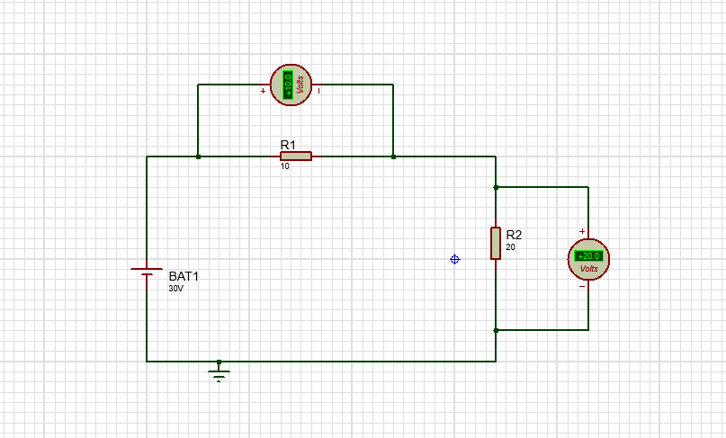

Apparatus:
Software used: Proteus 8 Professional
(i)Voltmeter, (ii)Resiglor,(iii) Power Supply,(iv) Connecting wires
Working procedure:
1. I made the connection as shown in the circuit diagram Using Proteus 8 Professional.
2. I measured the voltage across each resistor.
3. I verified Kirchhoff's Voltage Law (KVL).
• I measured the voltage across each pesistor in the dosed loop.
• I calculated the algebraic sum of the voltages.
• I verified that the sum was Indeed zero.
• I measured the voltage across each resistor.
• I calculated the voltage divider batio for each resiston.
• I compared the calculated and measured vottage.
4. I assumed the current flowing through each pesistor as 1,12. un
5. I assumed the direction of cuppent flowing through each branch.
6. I measured the current flowing into the top node of the circuit from each of the two branches.
7. I pecorded these measured cuppents.
8. I then the two cuppents to verify they were zero, or close to zero, confirming that the sum of incoming cupperds is equal to the sum of outgoing Cuppents.
9. For KVL. I measured VR₁ , VR₂ and applied KVL as per the observation table and recorded these measured Voltages.

Calculation: For KVL,

R₁=10
R₂=20
V=30v

V₁ =$\frac{R_{1}}{R_{1}+R_{2}}$ $×V$
= $\frac{10}{10+20}$ $×30$ = 10 v

V₂ =$\frac{R_{2}}{R_{1}+R_{2}}$ $×V$
= $\frac{20}{10+20}$ $×30$ = 20 v

$∴$Total valage , V =10+20=30v

Similarly,
V₁ = $\frac{20}{20+30}$ $×120$
=48 V

V₂ = $\frac{30}{20+30}$ $×120$
= 72 v
$∴$Total valage , V =48+72 = 120v

For KVL,
SL No | Input Voltage (V) | VR1 (V) | VR2 (V) | Total Voltage (V) (calculated) | Total Voltage (V) (Theoretical)
1 | 30 | 10 | 20 | 30 | 30
2 | 120 | 48 | 72 | 120 | 120
3 | 180 | 72 | 108 | 180 | 180
4 | 240 | 96 | 144 | 240 | 240

Result and Discussion:
1. The sum of voltage (calculated) is Gov and Voltage (theoritical) is Gov
We have compared the measured values are a little diviated from the theoritical values for calculation and data entry.
Thus the KVL is verified successfully.
Conclusion: In a dosed circuit, the algebric sum of all the EMF and all the voltage drops is zero, hence Kirchhoff's law voltage. is verified.

